FROM THE PRESIDENT, Dr Gilbert Owusu

Dear Colleague

Please consider standing for election to General Council (GC). GC membership can be extremely rewarding both personally and professionally, and GC members are crucial to the achievement of the OR Society’s aims.

Being a member of GC gives you a chance to meet, work, and build friendships with able, committed people from across the whole range of the OR profession. It gives you insight into the OR Society’s activities – its publications, events, promotions, outreach – and into the wider OR community across academia and practice. It gives you experience of governance, strategising, committee-work and decision-making that you may not get in your day-job. And it gives you a chance to take a hand in shaping the services and the future of the OR Society and thus of the profession. For people in early or mid-career, it is an invaluable opportunity to gain novel experiences, and to develop higher management skills. And at the other end of your career, it is a way of keeping engaged with the profession and continuing to make a difference.

Being a member of GC is undoubtedly a substantial commitment. GC members are expected to attend two Council meetings per year and two further meetings of their subcommittee. Over recent years, we’ve been running these meetings virtually, but may look to switch some of them back to face-to-face. These meetings will generate additional work, including reading and considering the papers, and taking on follow-through tasks; though the additional work can normally be undertaken at whatever time is convenient to you. A GC member should typically expect to spend 6-8 days each year on Council business; and should expect to sign up for a 3-year term.

GC membership can also be a gateway to chairing a subcommittee and joining the Board: additional responsibilities that carry commensurately greater rewards.
The attached document contains detailed information about how the OR Society works, and what GC (and Board) members do. It should help you understand the role better. I also hope it helps inspire you, as without Council members, we would be unable to provide the wide and varied offering that has been so influential, and so much appreciated by our members, over the last 70 years.

If you wish to go ahead, first, you must find six OR Society members who will nominate you. This can be done by asking your nominees to sign a paper copy of the nomination form (downloadable from our website) or by getting them to complete an electronic nomination form (which needs them to log in to the website).

At the end of the nominations stage, there may be an election (unless there are no more candidates than there are vacancies). You will be asked to provide a short (150 words max) statement to help voters to choose.

The nominations process ensures that all candidates are recognised as being of sufficient status in the OR Society to be worthy of taking on the role. However, the election system means that you may not be elected to GC on your first attempt. I hope that won’t put you off, but instead will whet your appetite for what is one of the most interesting, satisfying and important volunteer roles in the OR community.

Yours faithfully

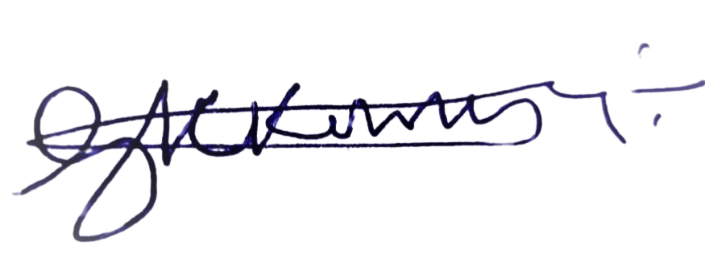

Gilbert Owusu
OR Society President 2023/24

